

**MINUTES OF THE 11TH ANNUAL GENERAL MEETING OF THE COUNTY PENSION FUND HELD AT THE EDGE HOTEL & CONVENTION CENTRE, COLLEGE OF INSURANCE, NAIROBI ON TUESDAY 9TH JULY 2024 STARTING FROM 8:30 A.M.**

**PRESENT:**

**CORPORATE TRUSTEE:** Mr. Victor Odendo - On behalf of Corporate Trustee

**ADMINISTRATOR:** Mr. Maurice Nduranu - Chairman

Dr. Hosea Kili, OGW - Director

Dr. Sheikh Ibrahim Lethome - Chairman Salih Scheme

Mr. Joseph Rono - Director

Management & Staff

**IN ATTENDANCE**:  Hon. Teresia Mbaika - PS. Devolution

H.E Mutahi Kahiga - Gov. Nyeri County

Hon. Roba Duba - Gen Sec CG Workers Union

Mr. George Kibore - Sec Gen. Kenya Union of CO

Hon. David Kones - DG. Nakuru County

Hon. Tamalinya Koech - DG. Narok County

Hon. Fred Lengees - Speaker, Samburu County

Hon. Vincent Kemboi - Speaker, Baringo County

**FUND MANAGERS**: Mr. Nicholas Ithondeka - Co-op Trust Inv. Services Limited

**CUSTODIANS**: Mr. George Mwangi - Equity Bank

**AUDITOR:** Mr. John Muhalia - Deloitte & Touche (Auditors)

**RETIREMENT BENEFITS** Mr.Jackson Nguthu - RBA

Ms. Caroline Wabwire - RBA

**AUTHORITY:**

**OTHER** H.E. Abdul S. Shariff Nassir - Governor Mombasa County

**STAKEHOLDERS** Mr. Ezra Ngoje - County Pensioners Association

**AND GOVERNMENT** Mr. John Gibore - Kenya Union of Clinical Officers

**OFFICIALS:** Mr. Joel Karuri Maina - Speaker, CA of Nakuru

**MEMBERS & EMPLOYERS:**

Governors and Deputy Governors - Delegates

Water and Sewerage Companies - Delegates

Retirement Benefits Authority - Delegates

Speakers of the County Assemblies - Delegates

Members of the County Assemblies - Delegates

Clerks of the County Assemblies - Delegates

Majority and Minority Leaders - Delegates

Leaders of Trade Unions - Delegates

County Union Representatives - Delegates

County Public Service Board - Delegates

Pensioners Association - Delegates

KCGWU Branch Chairpersons - Delegates

Directors/Executive Members - Delegates

CPSB Chairmen and Secretaries - Delegates

Members - Delegates

**AGENDA:**

1. Introduction and opening remarks
2. Reading of the Notice of the meeting
3. Reading and taking note of the minutes of the 10th Annual General Meeting held on 20th July 2023
4. Presentation of the Investment Managers reports
5. Presentation of the Scheme’s Custodian Reports
6. Presentation of the Financial Statements and Audited Accounts FY 2023
7. Presentation of the Chairman’s report
8. Presentation of the Administrator’s report
9. Presentation of the Corporate Trustee’s report
10. Presentation by Stakeholders
11. Address by Chief Guest
12. Award Ceremony
13. Questions and Answer
14. Vote of thanks

**MIN 1: 9.7.2024:** **INTRODUCTION & OPENING REMARKS**

The meeting was called to order at 9:30 a.m. and opened with a word of prayer from both Peter Mwaniki and Sheikh Ibrahim Lithome.

The Group PR Manager introduced the leadership of various employers and leaders representing employees in various capacities.

Dr. Ben Kajwang the CEO of the venue gave his remarks and welcome the participants to the venue.

**MIN.2: 9.7.2024: READING OF THE NOTICE OF THE 11TH ANNUAL GENERAL MEETING**

The Notice convening the 11th Annual General Meeting of the County Pension Fund was read by the Board Secretary. It was noted that the Notice had been published in the two daily newspapers (Daily Nation and the Standard) as required and within the statutory timelines.

The agenda was ADOPTED as tabled as proposed and seconded by Mr. **Josiah Munyasia** from Kitui County and **Paul Kiongo** from Taita Taveta County respectively.

**MIN.3: 9.7.2024: CONFIRMATION OF MINUTES OF THE 10TH AGM HELD ON 20th JUNE 2023**

The minutes were taken as read and confirmed as a true record of the deliberations of the Meeting as Proposed and Seconded by **Mr. Nicholas Moseti** from Kisumu Water and **Mr. Justus Momanyi** from Gusii Water Company respectively.

**MIN. 4: 9.7 2024: PRESENTATION OF THE INVESTMENT MANAGERS’ REPORT**

Presentation made by Mr. Nicholas Ithondeka, CEO Co-op Trust Investment Services, on behalf of the other fund managers being African Alliance, CIC and GenAfrica.

The fund manager highlighted in brief the performance of the Scheme FY 2023 as below:

Fund value and net returns for the conventional fund for the last 5 years

The asset summary comparatives

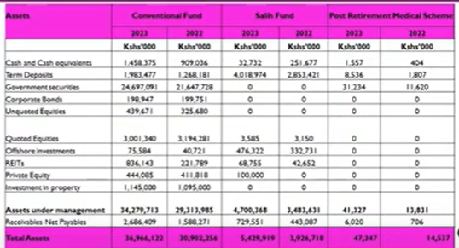

The asset allocation summary

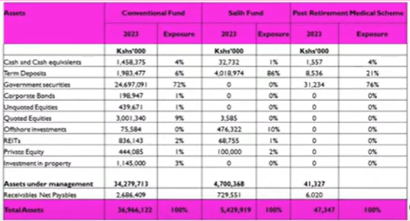

Asset allocation for the conventional fund

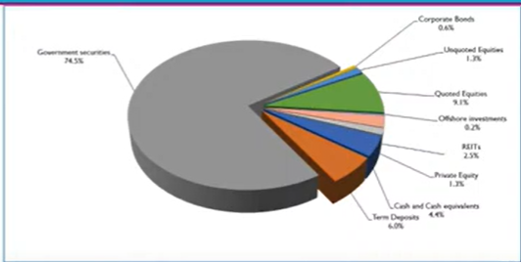

Fund value growth (Conventional Fund)

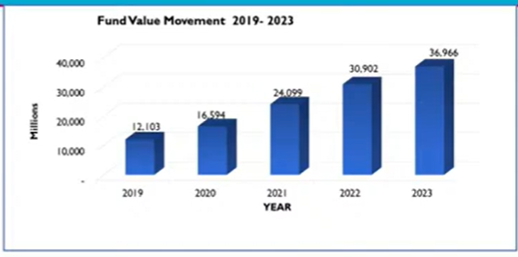

The report was ADOPTED by members as presented.

**MIN. 5: 9.7.2024: PRESENTATION OF THE CUSTODIAN REPORT**

Presentation was made by Mr. Kelvin Musa, from NCBA Bank on behalf of the other custodians, being Equity, KCB, and Stanbic Banks.

The Assets summary for the period under review and Growth in the Fund Value FY 2023 was presented below:

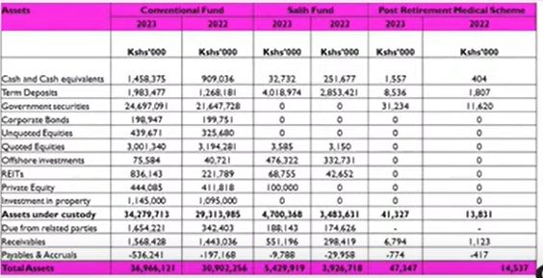

Growth in Fund Value (Combined) Kshs ,000

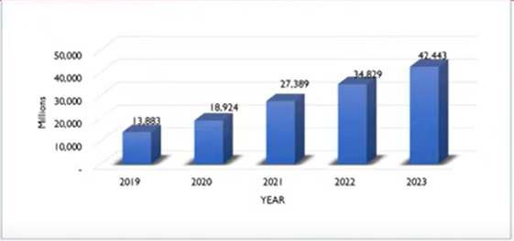

The report was ADOPTED by members as presented.

**MIN. 6. 9.7.2024: PRESENTATION OF THE FINANCIAL STATEMENTS & AUDITED ACCOUNTS FOR THE YEAR ENDED 31ST DECEMBER 2023**

Mr. John Muhalia on behalf of the Scheme Auditors Messrs. Deloitte & Touche presented their Report to the members and confirmed that the audited financial statements reflected the true and fair financial position of the Scheme as at 31st December, 2023.

The Accounts were ADOPTED by members as proposed and seconded by **Mr. Kimondo Kariuki** and **Mr.** **Siya Lagat** respectively.

**MIN: 7.9.7.2024: PRESENTATION OF THE CORPORATE TRUSTEE’S REPORT**

Mr. Victor Odendo reported that the County Pension Fund was established and registered under the Retirement Benefits Authority (RBA) Act. He noted that County Pension Fund is a Defined contributions Scheme. The rules of the Fund, provides for the staff of County Governments, associated organizations, and approved reciprocating bodies. It is a tax-exempt entity as approved under the Income Tax Act.

He emphasized that the principal objective of the Fund is to provide pension and other retirement benefits to employees of the sponsors and other individuals and associated members of the Fund upon their retirement from service and relief for the dependents of deceased employees.

Through innovation, County Pension Fund registered a Shariah Compliant sub-fund Salih to cater for members who prefer investments in Sharia-compliant products. This Fund has attracted members and has experienced growth. He appreciated the continued support from the Shariah Committee to ensure that scheme remains the largest shariah scheme in the region

He reported that active membership has risen and is still growing and as the Corporate Trustee, reassure members that they will continue to support the scheme through benchmarking on governance and best practices including the sustainability agenda based on sound polices to ensure the scheme becomes green.

He assured members that the scheme is safe, and no assets have been used as collateral and confirms that the Board held all mandatory meetings as provided in the annual report. As Trustees they discharged their fiduciary role, and no conflict of interest arose during the year.

In conclusion, he appreciated the Management Team in their efforts to ensure seamless administration of the scheme which is affirmed by the external audit carried out that confirms that the scheme affairs are carried out in an accountable manner is a going concern.

**MIN. 8: 9.7.2024: PRESENTATION OF THE ADMINISTRATOR’S REPORT**

**Dr. Hosea Kili**, the Group Managing Director presented the Report for the year ended 31st December 2023 with the following highlights:

* Net assets increased to Ksh.39B from 32.8%
* Shariah a segregated fund increased to Ksh.1.5B from 636.8M in 2022
* The PRMF another segregated fund stood at Ksh.32.8M from Ksh.14.5M in 2022
* Encouraged all members in the schemes under administration and governors to join the PRMF to start saving for medical costs in old age while still healthy
* He proposed that Employers through resolutions that out of the pension contribution ratio of employer and employee of 15% and 12% a deduction of 2% be made from both parties towards PRMF
* The Administrator is managing over 200B in total assets for all the schemes under their administration
* The scheme is considering diversifying in offshore investment to maximize the allowable limit of 15% by RBA to ensure the scheme continues to scale greater heights
* Thanked all members who honored the invite to attend the meeting and encouraged members to visit the CPF branches across the country, visit the digital platforms and social media channels.

The Administrators’ Report was adopted by members as presented.

**MIN.9: 9.7.2024 PRESENTATION BY A SELECT LIST OF STAKEHOLDERS**

**Remarks by the Governor, Mombasa County**

His Excellency the Governor of Mombasa County, Hon. Adul Swammad Shariff Nassir invited all Members and thanked the organizers and particularly Mombasa members for attending the meeting.

He reassured members that the Scheme has his full support and also promised to clear the outstanding debt for the county to ensure seamless payment as members retire.

**Remarks by Sheikh Ibrahim Lethome, Chairman Salih Fund**

He thanked the support from Administrator in support of the first Shariah compliant pension scheme. He informed members that shariah investment does not permit money to beget money and must have certainty. He informed members that shariah is not restricted for the Muslim faith but everyone is free to participate and invest in shariah-compliant products.

He emphasized that the members of the Salih Committee were not employees of CPF but were there to offer expert advice on how members' contributions would be invested in a Shariah-compliant manner, supervise the investments, and carry out audits. In conclusion, he gave credit to CPF for floating the first Shariah-compliant product, ’Sukuk Bond’.

**Remarks by Mr. Ezra Ngoje, Chairman County Pensioners** **Association**

Mr. Ngoje started by appreciating all the Chief Guest and other stakeholders attending the meeting. He observed that pensioners are prone to health challenges due to old age and pension is critical to ensure that life in old age is bearable.

**Remarks Hon. Roba Duba, the General Secretary Government Workers Union**

He informed members that he is one of the key stakeholders being the 2nd highest earning pensioner in the Scheme and having held leadership roles in the local government, regional government representing workers and understands their challenges, the greatest one being outstanding debts.

He urged the Governors to take charge of the welfare of workers in the counties by reaching out to SRC to implement salary increments and support the proposal to fund PRMF from the pension contribution amount.

*Members resolved to pass this motion for employers to formally pass this resolution for implementation*.

He also urged the young members to join the scheme to ensure their retirement benefit is realistic at retirement.

He requested RBA to appropriate their power in managing seamless pension administration in the public sector.

**Remarks by John Keya, on behalf of the RBA CEO**

Conveyed greetings from the CEO Charles Machira and the Director Supervision Mr. Jackson Nguthu. He introduced the respective scheme officers.

* The Regulator has introduced several policies including; approval of national pension policy to enhance governance, trustee remuneration of scheme management, corporate trustee regulations, IDD regulations, manager and custodian amendment on valuation of securities, practice notes on determining processing and discharging benefits.
* Confirmed that all the schemes are well managed except for funding levels and to this end implores sponsors to honor their obligations.
* The Regulator reaffirms its commitment to promote growth of the benefits sector and advisory to government to achieve their vision of an inclusive retirement. To this end, he urged members to take advantage of AVC.

**Remarks by Michael Kagika, National Treasury on behalf of the PS Treasury**

The National Treasury is committed to ensure pension systems work in a stable environment to secure pension through comprehensive framework that supports pension management.

The National Treasury undertakes the following in support of the benefits sector:

* Ensure sustainability of the systems to ensure an income through members’ old age. To this end, the Treasury is running an actuarial valuation, seeking inclusivity for all.
* Encourage schemes to build capacity in that space and that schemes must adopt technology to improve service delivery and transparency.
* Fostering collaboration among all stakeholders and continuous engagement
* Beware of emerging challenges and give solutions
* As for debt for future remittances, all future payments will be done from IFMIS to ensure no more debt accrual, there is a Taskforce comprising CS National Treasury, PS and other stakeholders to address the issue of debt.

**MIN. 10: 9.7.2024: ADDRESS BY THE CHIEF GUEST**

Hon. Teresiah Mbaika, the PS for State Department of Devolution, which is under the Office of the Deputy President confirmed that they are consulting on pending bills and soon the outcome will be realized. She welcomed the chief guest.

**H.E. Gladys Wanga**

She encouraged the Union Representative to keep reminding the relevant Council committee on the workers’ welfare. Her remarks included:

* Congratulated CPF as trailblazers in the pension sector
* Aligning investment strategies with member needs has provided solutions to members
* Affirms unwavering support for the CPF Fund and acknowledges the support of the collaborative partnership on the County HQ investment. This was supported in law through approval by all relevant stakeholders ensuring that the pension money is protected and there is guarantee returns and no loss occasioned.
* COG appreciates continued collaboration and support through devolution conferences, capacity building for council staff.
* Thanked CPF on timely payment of benefits at retirement
* Governors are aware of the delay in remittance of member contributions but are working closely with National Treasury to ensure this practice does not continue
* Urged CPF to explore higher yielding investments and participate in affordable housing for the counties.

**MIN.11: 9.7.2024: AWARDS & RECOGNITION**

The following Sponsors were recognized for various awards under various categories. The award ceremony was facilitated by Ms. Irene Mbonge, the CPF Group Head Corporate Communications and Public Affairs.

1. **Consistency in Remittance of Monthly Contributions**
2. **County Governments**
3. Kitui County
4. Bomet County
5. Kisii County
6. **Water Companies**
7. Nairobi Water & Sewerage Company
8. Eldoret Water & Sanitation Company
9. Kisumu Water & Sewerage Company
10. **Consistency in Remittance of individual Monthly Contributions**
11. Homa Bay County
12. Mandera County
13. Lamu County
14. **Consistency in Membership Growth**
15. **County Governments**
16. Trans Nzoia County
17. Wajir County
18. Meru County
19. **County Assemblies**
20. Nairobi County Assembly
21. Kilifi County Assembly
22. Kirinyaga County Assembly

1. **Special mentions**
2. Nursing Council
3. Weston Hotel
4. Nairobi Center for International Arbitration
5. Action Results for Change
6. Kenya Leather Development
7. **Overall Sponsor of the Year**
8. Kitui County Government

**MIN.12: 9.7.2024:** **QUESTION AND ANSWER SESSION**

Several questions were asked, by members, about the welfare of their scheme. The questions touched in various areas including whether members can invest on the Anderson Kisumu Project; who the members of Taifa Pension Scheme were; why the DB Scheme was decreasing on the Fund value; the investment on immovable assets; the merger between Laptrust and Lapfund; on how the debt owed to the schemes was being managed, *inter alia*.

The Administrator of the schemes took time to respond to all the raised issues. Members were also requested to refer their further questions, if any, through the social platforms for the schemes wherein the same would be answered satisfactorily by the management thereto.

**MIN.13: 9.7.2024: VOTE OF THANKS**

The vote of thanks was done by Dan Awendo a member of the Board of Trustees of Laptrust Scheme. He appreciated all the stakeholders, the Chief Guest, the Governors and Deputy Governors, Pensioners, Scheme sponsors (County government and County Assemblies, RBA, Union officials the Chairmen of all Boards, the GMD/CEO, the Corporate Trustee, CPF staff, the Choir, service providers, the organizers, MC of the day and the caterers.

There being and being no other business, the meeting ended at **2:30 p.m.** with a closing prayer from Mr. Joshua Moilo**,** the CPF Group Finance Manager.

**Signature in Confirmation of Minutes:**

**CHAIRPERSON, BOARD OF TRUSTEES DATE**